Optimizing Bi-Objective Multi-Commodity
Tri-Echelon Supply Chain Network

Gholam Hassan Shirdel^{1,*}, Elnaz Pashaei²
¹Faculty of Basic Sciences, University of Qom, Qom, Iran.
shirdel81math@gmail.com
²Department of Industrial Management, Azad University of Qazvin, Iran
e.pashaei8@gmail.com

Abstract
The competitive market and declined economy have increased the relevant importance of making supply chain network efficient. This has created many motivations to reduce the cost of services, and simultaneously, to increase the quality of them. The network as a tri-echelon one consists of Suppliers, Warehouses or Distribution Centers (DCs), and Retailer nodes. To bring the problem closer to reality, the majority of the parameters in this network consist of retailer demands, lead-time, warehouses holding and shipment costs, and also suppliers procuring and stocking costs all are assumed to be stochastic. The aim is to determine the optimum service level so that total cost could be minimized. Reaching to such issues passes through determining which suppliers nodes, and which DCs nodes in network should be active to satisfy the retailers' needs, the matter that is a network optimization problem per se. Proposed supply chain network for this paper is formulated as a mixed integer nonlinear programming, and to solve this complicated problem, since the literature for related benchmark is poor, three ones of GA-based algorithms called Non-dominated Sorting Genetic Algorithm (NSGA-II), Non-dominated Ranking Genetic Algorithm (NRGA), and Pareto Envelope-based Selection Algorithm (PESA-II) are applied and compared to validate the obtained results.

Keywords: Supply Chain Management; Tri-Echelon Network; Mixed-Integer Nonlinear Programming; NRGA; NSGA-II; PESA-II;

1. Introduction
Supply Chain Management (SCM) is a strategic approach that contains the processes like Retailer demand management, Order fulfillment, Manufacturing management, Procurement, Product commercialization, Returns management, and etc. [1]. It also could involves the functions within and outside a company that enable a value chain to make products and provide services for the retailers from another point of view [2]. SC usually consists of retailers, distribution centers (DCs), plants, and suppliers. In SC raw material primed, products are manufactured at one or more plants, commodities are sent to warehouses and lastly might be shipped for retailers.
SCM faces with handling a network of inter-connected businesses involved in the ultimate provision of commodity so that packaging services could be done by end retailers. So with such an aspect, SCM or in a better term Supply Chain Network (SCN), envelopes all the requirements for synchronizing activities like material priming, material processing to final products and distributing of the manufactured products to retailers. Usually the goals of SCN are as minimizing system costs and provisioning the service level requirements. Such a comprehensive system is a draft that depicts the quantities of commodities, location of DCs, and even time for production process. There are numerous autonomous identities each of which tries to satisfy their own objective in a SCN. So trying to solve a real SC problem might be so hard and requires more than one objective to be satisfied. Such a problem entitled as multi-objective optimization problem that has numerous Pareto solution. Attaining to the matters like lower costs, shorter processing time and lead-time, lower stock, larger commodity diversities, better reliable delivery time, improved quality, and priming the coordination between demand, procurement and manufacturing that all are known as KPI for business owners, need a proper and well-devised SCN.
SCM could be summarized into three main processes: SC structuring, SC programming, and SC control and monitoring. In SC structuring we make strategic plan such as plant location, capacity of plants and the quantity of materials that are required in producing operations or distributed among facilities. The focus of structuring in traditional SCM mainly devoted on single objective, as minimize the cost or maximize the gain, whilst a real SC have to be optimized with more than one. In fact real SC problems usually can be formulated as a case of multi-objective problem that needs an algorithm capable to search the space of objectives in a short run-time.
In many of the classical SCN structuring, the goal is sending/receiving merchandise from/to a layer to/from the other(s) so that procuring costs for both strategic and operational functions are minimized. As a case, Amiri [3] structured a SC model for catching the best strategic decisions on locating plants and DCs for commodities dispatching from manifesting site to the retailers side, subject to the goal of minimum total costs of the DCs in network. In another case, Gebennini, et al. [4] offered a three-layered manufacturing–dispatching system for the minimum costs. Network sketching faces with relations between various SC portions together, which are mutually under risks and uncertainties through the whole chain; an issue that prepared a controversial problem for SC decision-making process, so that recent goals are propounded. The uncertainties involved in SC networks could be depicted into three divisions based on the supplier layer, the receiver layer, and in the DC layer. Since reversible logistic decisions and its relation to the SCN scaffolding is so difficult and costly, the momentous of the interactions between these decisions is vastly enhanced under uncertainty. Mohammadi Bidhandi and Mohd Yusuff [5] proposed a stochastic SCN model as a two-level program under both strategic and tactical decisions. In their model retailer demands, cost of operation, and the capacity of facilities could be uncertain as all can deadly have effects on the strategic decisions. For strategic level, Snyder [6] considered a RFLP for locating DCs level of a SC under uncertainty when facilities could to have random failures. Murthy, et al. [7] mentioned that uncertainty for strategic level is the most difficult and important issue to be considered. For tactical level, Van Landeghem and Vanmaele [8] considered a SC structuring problem that consists the merchandise and raw material dispatching. Moreover, Jamshidi, et al. [9] proposed a multi-echelon bi-objective SCN structure involved several transportation options for each level with variable costs and restrictions on capacity.
Some other approaches in literature which are noticeable for SC problems could be taken into account as Moncayo-Martínez and Zhang [10] that proposed an algorithm based on a Pareto AC optimization for minimizing both the SC current cost and the total lead-time for a family of commodities. In another work, Cardona-Valdés, et al. [11] studied the structure of a two-echelon SC with uncertain demand. An important contribution in this work is deployment of TS within the multi-objective adaptive memory programming architecture to prepare optimal Pareto Fronts for a two-stage stochastic bi-objective programming problem. While Shankar, et al. [12] considered optimization of strategic structure and DCs decisions for a tri-echelon SC simultaneously, and also for solving the problem a MOHPSO have proposed in their work. Beside, Marufuzzaman, et al. [13] considered a two-stage stochastic model used for scaffolding and handling the biodiesel SC. Their model catches the effects of biomass supply and uncertainties in technology on SC related decisions.
In this paper optimizing a bi-objective tri-echelon multi-commodity SC problem is aimed. The proposed network would be consists of some suppliers, DCs, and retailers nodes. Putting the existing models to practice and bring them to reality is the contribution of this paper. This is attained using more realistic and applied supposed in terms of uncertainties involved in all the three strategic, tactical, and structuring the proposed SCN levels. Depicting it in more specific, the fixed and variable costs, retailers demand, total available production time for plants, setup and production time of producing products, all are assumed stochastic internal parameters follows uniform distributions; a common probability model suitable that is for many natural stochastic processes based on the central limit theorem. Moreover, the goal is to determine the active suppliers and DCs assumed as Boolean variables so that optimum paths for retailers' demands satisfaction could be achieved. In another word, this paper aim is to determine the optimum network for satisfying retailers' demands subject to the two goals of minimum cost and maximum service levels.
The problem has formulated to obtain the deterministic model of a bi-objective MINLP. The proposed mathematical model of this work is hard to be resolved by common analytical or exact approaches, so three ones of MOGA are utilized to find Pareto Fronts; and since the literature for benchmarks to validate the obtained solutions is poor, these applied algorithm called NSGA-II, NRGA, and PESA-II are compared together via six numbers of cited indexes. Finally, numerical example is presented and detailed comparison results are exposed and discussed.
The rest of this paper is to explain problem background in section ‎2, after that in section ‎3 the proposed problem has formulated. Then solving procedure consist of current approaches for dealing with SCN problems, applied algorithms and their characteristics considered in section ‎4. After that, experimental results resolved in section ‎5. A comparison between triplex calibrated algorithms based upon the defined indexes considered in section ‎6. Lastly, conclusions and some guidelines for future studies are provided in section ‎7.

2. Problem Background

In the recent few years, it has become obvious that many companies have reduced operational costs as much as possible. They are discovering that effective SCM is the next needed step to take in order to increase profits and market share [14].
The first study of location problem began in 1909 by Alfred Weber’s et al. who was working on positioning a single warehouse with aim to minimize the total distance between it and customers [15]. Later, they worked on locating switching centers in a communication network and police stations in a freeway system. After that many practitioners worked on formulating facility location problem which derives a single solution enabled to be implemented at one point in time. These basic location problems are categorized into median problems [16], covering problems [17, 18], etc. per se. Later researches focused on facilities location that dictates flows between facilities and demands. This type of problems has called location-allocation problems.
The multi-commodity problem considers fixed location costs, linear transportation costs, and assume that each warehouse can be assigned at most one commodity which are studied by Warszawski and Peer [19]. After that, Geoffrion and Graves [20] considered the extended version of multi-commodity location problem as capacitated, and developed a model to solve the problem of designing a distribution system with optimal location of the intermediate distribution facilities between plants and customers. They also explained the risk of using heuristic models in distribution planning. Plant location problem has two derivatives as capacitated and uncapacitated per se. These two types of problem are studied by [18, 21-23].
The location decisions without considering inventory and shipments cost can be tend to sub-optimality. Hence facility location problems are given a new orientation with integrated approach. So a facility location model must consider production, inventory, distribution, and location that associated with cost. The first researcher who used the dynamic programming to determine optimal location and relocation strategy was Ballou [24]. After that, Scott [25] developed multiple dynamic facility location-allocation problems. Also an integer programming model was developed by Wesolowsky and Truscott [26] to extend the analysis of multi-period node location-allocation problems. Erlenkotter [27] in another work examined a dynamic, fixed charge, capacitated, cost minimization problem with discrete interval times.
One momentous issue in SCM study is overcoming to more than one objective such as minimizing costs, maximizing profits and improving customer services. Different methodologies were developed for solving multi-objective optimization problems such as the weighted-sum method, the ε-constraint method, the goal-programming method and fuzzy method [28-30]. In this context, Sabri and Beamon [31] presented a multi-objective technique for simultaneous strategic and operational planning in SC design. The model considered production, delivery, demand uncertainty, and a multi-objective performance vector for the entire SC network. Related to the mathematical model of this paper, Nozick and Turnquist [32] proposed a model that minimizes costs and maximizes services.
For further study the multi-objective location models published by Shen, et al. [22], can be referred. In another hand, Chen [33] proposed a model for optimizing conflicting objectives such as participant’s profits, the average customer service levels and the average safe inventory level. Kopanos, et al. [34] presented a multi-objective stochastic mixed integer linear programming model for SCM too. They solved their model using the standard ε-constraint method and branch and bound techniques. Graves and Willems [35] applied an optimization algorithm to find the best inventory levels of all sites on the SC. Nowadays the GA considered as one of the most used optimization tools which applied in the resolution of several types of linear and non-linear optimization problems [36]. However, in real problem conception of SC decisions, one is encountering with multiple choices. The main difference between the above mention issues that came in hand through literature surveying, with the proposed model of this paper is that this paper considers supplier and inventory location (as DCs) by determining their Boolean value (i.e. null or active) in proposed network and also material flow decisions, whilst pre-mentioned works consider other minded matters that considered in detail.

Formulating the Proposed Supply Chain Problem
As shown in Figure 1 the assumed tri-echelon SCN for this paper consists of suppliers to the left, distribution centers (DCs) in the middle, and retailer nodes to the right. It has supposed that this proposed SC Network:
- Has an integrated structure consisting both potential supplier and potential DCs designed to procure retailer demands for multitude commodities.
- Has predefined numbers of suppliers and DCs with known capacities.
- The number of its retailers and their demands distribution are known.
- It operates in an uncertain circumstance, i.e. its main interior parameters as demands, lead-time, procure and transportation costs, and holding costs of inventory for commodities all are supposed to be uniform random variables with known average and variance (Table 1).
- Its DCs and suppliers all are supposed to be potentially operational at the beginning of the constructing network.
- Its suppliers and DCs do their procuring, shipment, and holding duties perfect.
- Any retailer receives its demand for a specific merchandize only from one DC.
- Shortage cannot happen at retailer nodes in any form.
- More than one supplier can replete the demand of a specific DC.
- More than one DC can replete the demand of each retailer.
Supplier-2-DC Lead-time
Suppliers
DCs
Retailers
.
.
.
Figure 1. A Tri-Echelon SCN

.
.
.
.
.
.

According to the inventory theory, the j^{th} warehouse daily demand distribution for k^{th} commodity is$N(D_{j}^{k},θ_{j}^{k})$. The $D_{j}^{k}$ is the average of j^{th} warehouse daily demand for k^{th} commodity and $θ_{j}^{k}$ is the variance of j^{th} warehouse daily demand for k^{th} commodity. The formulas for calculating $D_{j}^{k}$ and $θ_{j}^{k}$ are as Equation ‎(1):
$$D_{j}^{k}=\sum_{i=1}^{I}{μ_{i}^{k}.x_{ji}^{k}}, θ_{j}^{k}=\sum_{i=1}^{I}{υ_{i}^{k}.x_{ji}^{k}}, ∀ j=1,2,…,J , k=1,2,…,K$$ | - .
The expected value of k^{th} commodity lead-time delivery in j^{th} warehouse could be calculated by the Equation ‎(2):
$$E_{j}^{k}=\sum_{m=1}^{M}{L_{mj}^{k}.y_{mj}^{k}}, ∀ j=1,2,…,J , k=1,2,…,K$$ | - .
The average and variance of exact k^{th} commodity demand in lead-time for j^{th} warehouse are given by Equation ‎(3) and ‎(4), while $∀ j=1,2,..,J , k=1,2,…,K$:
$$D_{j}^{'k}=E_{j}^{k}.D_{j}^{k}=E_{j}^{k}.\sum_{i=1}^{I}{μ_{i}^{k}.x_{ji}^{k}}, ∀ j=1,2,…,J , k=1,2,…,K$$ | - .
$$θ_{j}^{'k}=E_{j}^{k}.θ_{j}^{k}=E_{j}^{k}. \sum_{i=1}^{I}{υ_{i}^{k}.x_{ji }^{k}}, ∀ j=1,2,…,J , k=1,2,…,K$$ | - .
Therefor${SS}_{j}^{k}$, the k^{th} commodity buffer quantity for j^{th} warehouse could be calculated by Equation ‎(5):
$${SS}_{j}^{k}=z_{1-α}.\left[\sqrt{θ_{j}^{'k}}\right], ∀ j=1,2,…,J , k=1,2,…,K$$ | - .

The j^{th} warehouse order point and optimum Quantity are as Equation ‎(6) and ‎(7):
$$r_{j}^{k}=D_{j}^{'k}+{SS}_{j}^{k}, ∀ j=1,2,…,J , k=1,2,…,K$$ | - .
$$Q_{j}^{*k}=\sqrt{\frac{2.A_{j}^{k}.β\sum_{i=1}^{I}{μ_{i}^{k}.x_{ji}^{k}}}{h_{j}^{k}}}, ∀ j=1,2,…,J , k=1,2,…,K$$ | - .
While for used indices :
i : | Number of Retailers
j : | Number of Warehouses (DCs)
m : | Number of Suppliers
k : | Number of Commodities

Considered on sets :
$S_{I}$ : | Set of Retailers $S_{I}=\left\{i | i=1, 2, …,I\right\}$
$S_{J}$ : | Set of Potential DCs $S_{J}=\left\{j | j=1, 2, …,J\right\}$
$S_{M}$ : | Set of Suppliers $S_{M}=\left\{m | m=1, 2, …,M\right\}$
$S_{K}$ : | Set of Commodities $S_{K}=\left\{k | k=1, 2, …,K\right\}$

The mathematical model for mentioned SC network is described as follow:

$$Objective 1:{ }f_{1}=Min\left\{\sum_{m=1}^{M}{g_{m}.z_{m}} + \sum_{j=1}^{J}{F_{j}.u_{j}}+β\sum_{k=1}^{K}{\sum_{m=1}^{M}{\sum_{j=1}^{J}{\sum_{i=1}^{I}{μ_{i}^{k}}. {rc}_{mj}^{k} .x_{ji}^{k}.y_{mj}^{k}}}}+β\sum_{k=1}^{K}{\sum_{j=1}^{J}{\sum_{i=1}^{I}{μ_{i}^{k} . {tc}_{ji}^{k} .x_{ji}^{k}}}}+\sum_{k=1}^{K}{\sum_{j=1}^{J}{\sqrt{2.A_{j}^{k}.h_{j}^{k}.\left[β\sum_{i=1}^{I}{μ_{i}^{k}.x_{ji}^{k}}\right]}}} +\sum_{k=1}^{K}{\sum_{j=1}^{J}{h_{j}^{k}.z_{1-α}.\sqrt{\sum_{m=1}^{M}{\sum_{i=1}^{I}{L_{mj}^{k}.υ_{i}^{k}.x_{ji}^{k}.y_{mj}^{k}}}}}}\right\}$$ | - .
$$Objective 2: f_{2}=Max\left\{\frac{\sum_{k=1}^{K}{\sum_{m=1}^{M}{\sum_{j=1}^{J}{\sum_{i=1}^{I}{μ_{i}^{k}.x_{ji}^{k} .y_{mj}^{k}}}}}}{\sum_{k=1}^{K}{\sum_{i=1}^{I}{μ_{i}^{k}}}}\right\}$$ | - .
Subject to:
$$\sum_{j=1}^{J}{x_{ji}^{k}}≤1, ∀ i∈S_{I}, k∈S_{K}$$ | - .
$$x_{ij}^{k}≤u_{j}, ∀ i∈S_{I}, j∈S_{J}, k∈S_{K}$$ | - .
$$\sum_{m=1}^{M}{y_{mj}^{k}}≤1, ∀ j∈S_{J}, k∈S_{K}$$ | - .
$$y_{mj}^{k}≤z_{m}, ∀ m∈S_{M}, j∈S_{J}, k∈S_{K}$$ | - .
$$\sum_{j=1}^{J}{u_{j}≤N}$$ | - .
$$\sum_{m=1}^{M}{z_{m}}≤R$$ | - .
$$\sum_{i=1}^{I}{μ_{i}^{k}}.x_{ji}^{k}+z_{1-α}.\left[\sqrt{\sum_{m=1}^{M}{\sum_{i=1}^{I}{L_{mj}^{k}.υ_{i}^{k}.x_{ji}^{k}.y_{mj}^{k}}}}\right]≤w_{j}.u_{j}, ∀ j∈S_{J}, k∈S_{K}$$ | - .
$$\sum_{j=1}^{J}{\left[\sum_{i=1}^{I}{μ_{i}^{k}}.x_{ji}^{k}\right]} .y_{mj}^{k}≤s_{m}.z_{m}, ∀ m∈S_{M}, k∈S_{K}$$ | - .
$$x_{ji}^{k}∈\left[0 , 1\right] , y_{mj}^{k}∈\left[0 , 1\right] , u_{j}∈\left[0 , 1\right], z_{m}∈\left[0 , 1\right]$$ | - .

The objective function 1 (Eq. ‎(8)) minimizes the total cost of setting up and operating the network and objective function 2 (Eq. ‎(9)) maximizes replenish rate or service level. The constraint in Eq. ‎(10) states the i^{th} retailer receives k^{th} commodity just from one warehouse. The constraint in Eq. ‎(11) specifies that variables are bounded. The constraint in Eq. ‎(12) enforces the k^{th} commodity demand of the j^{th} warehouse prepared just by one supplier. The constraint in Eq. ‎(13) states that if the m^{th} supplier is open, the j^{th} warehouse will receive its demand from m^{th} supplier. The constraint in Eq. ‎(14) indicates the maximum number of warehouses. The constraint in Eq. ‎(15) specifies the maximum number of suppliers. The constraint in Eq. ‎(16) ensures that j^{th} warehouse capacity is greater than the i^{th} retailer demand and its buffer. The constraint in Eq. ‎(17) enforces the supplier capacity must be greater than the warehouse capacity. The constraint in Eq. ‎(18) indicates the variables are binary variables. Table 1 and Table 2 depict the used notations.

Table 1. Notation Used in the Mathematical Formulation
Notation Used | Meaning | Distribution/  Value | Dimension
$$μ_{i}^{k}$$ | Average Daily Demand from i^{th} Retailer for k^{th} Commodity | U[70-120] | unit
$$υ_{i}^{k}$$ | Variance Daily Demand from i^{th} Retailer for k^{th} Commodity | U[10-25] | unit
$$F_{j}$$ | j^{th} Warehouse Opening Fixed Cost | 650 | $
$$h_{j}^{k}$$ | j^{th} Warehouse Holding Cost for k^{th} Commodity | U[70-90] | $
$$A_{J}^{k}$$ | j^{th} Warehouse ordering cost for k^{th} Commodity | 5$ | $
$$w_{j}$$ | Potential Capacity of j^{th} Warehouse | 750 | unit
$${tc}_{ji}^{k}$$ | Unit Cost of k^{th} Commodity shipping from j^{th} Warehouse to i^{th} Retailer | U[10-15] | $
$$g_{m}$$ | m^{th} Supplier Fixed Cost to be Selected/Accept to Procure | 1500 | $
$${rc}_{mj}^{k}$$ | Cost of Procuring, Stocking and Shipping k^{th} Commodity from m^{th} Supplier to j^{th} Warehouse | U[65-80] | $
$$s_{m}$$ | Potential Capacity of m^{th} Supplier | 500 | Per month
$$l_{mj}^{k}$$ | Lead-time for k^{th} Commodity from m^{th} Supplier to j^{th} Warehouse | U[2-3] | Day
R | The Maximum Possible Number of Supplier | 50 | unit
N | The Maximum Possible Number of Warehouses | 25 | unit
$$β$$ | The Number of Working-day Per Year | 220 | Day

Table 2. Decision Variables Used in the Mathematical Formulation
Notation Used | Definition
$$x_{ji}^{k}∈\left[0 , 1\right]$$ | 1, If the Demand of k^{th} Commodity for i^{th} Retailer is Satisfied by j^{th} Warehouse, Else 0
$$y_{mj}^{k}∈\left[0 , 1\right]$$ | 1, If the Stock of k^{th} Commodity for j^{th} Warehouse is Procured by m^{th} Supplier, Else 0.
$$u_{j}∈\left[0 , 1\right]$$ | 1, If j^{th} Warehouse is Open/Active, Else 0.
$$z_{m}∈\left[0 , 1\right]$$ | 1, If m^{th} Supplier is Selected for/Accept Procuring, Else 0.
$$Q_{j}^{k}≥0$$ | Optimum Quantity of k^{th} Commodity for j^{th} Warehouse
$${SS}_{j}^{k}≥0$$ | Buffer Quantity of k^{th} Commodity for j^{th} Warehouse
$$r_{j}^{k}≥0$$ | k^{th} Commodity Order Point for j^{th} Warehouse

Solving Procedure
Totally to solve complicated multi-objective optimization problems there are two approaches. In one, the problem is converted to a single-objective optimization using MCDM methods (proposed by Hwang, et al. [37]) at first, and then, a SOEA such as GA, PSO, SA, HAS, or ICA could be deployed to solve the single-objective problem in one single run [38]. But in another, a MOEA such as NSGA-II, NRGA, or PESA-II directly used to find an optimal set has named Pareto Optimal Front in a single run [39]. Since MOEAs are usually fast to find Pareto Fronts in a single run and also SOEAs need multitude runs for obtaining a Front, a MOEA might as well be utilized in this section to solve a complex bi-objective optimization problem at hand.
All in all, solving SCM problems using GA is a popular manner between practitioners of this context. as Tsai and Chao [40] applied an adaptive GA by a chromosomes’ repairing procedure for adapting gens' ordinal structure. In another work, Wang, et al. [41] considered a facility location and task allocation problem of a two-echelon SC with stochastic demands for gain maximization . They presented a GA with efficient greedy heuristics solve their problem. Prakash, et al. [42], primed a KBGA for optimizing a SCN. Altiparmak, et al. [43], used a GA to find the Pareto optimal set of a multi-objective four-echelon SC using different weighting method. Bandyopadhyay and Bhattacharya [44], proposed a tri-objective problem for a two-echelon serial SC. They considered modification of NSGA-II with an embedded mutation algorithm. In another work, Sourirajan, et al. [45] studied a two-stage SC with a single product replenished in a production facility and applied a GA to solve. Also LHA deployed in their work for comparison the obtained results.Zegordi, et al. [46] used a GA for solving a mixed-integer programming for a two-stage SC problem containing scheduling of merchandizes and vehicles.
Among MOEAs, the NSGA-II for the sake of its popularity, capability to solve similar, and ease of use is selected. Furthermore, as said since the literature for benchmark to validate the obtained results is poor, a couple of multi-objective evolutionary algorithm called NRGA and PESA-II are utilized as well. Finally, a numerical example and comparison results between these calibrated algorithms are presented and discussed.

Non-Dominated Sorting Genetic Algorithm (NSGA-II)
NSGA-II which introduced by Deb, et al. [47], is one of most used and propounded GA-based algorithms for solving multi-objective problems [48]. It commences by a randomly generated population with size nPop (as one of the algorithm parameters). During the iterations, the objectives values for each individual of the population would be assessed via an evaluator function. After that, the population individuals would be ranked based upon the non-dominated sorting process. The individuals of population label a rank equal to their non-dominated level so that the first front contains individuals with the smallest rank; the second front corresponds to the individuals with the second rank; and so on. In the next stage, the Crowding Distance between members on each front would be calculated. As a Boolean tournament selection operator based on a crowded-comparison operation is used, it is necessary to reckon both the rank and the crowding distance for each population individual. So, two members would be caught between the populations by this operator at first. In continue, the member with larger Crowding Distance is selected if they share an equal rank. Otherwise, the member with the lower rank would be chosen. Then, a new offspring population with a size of n would be created through the selection, the crossover and the mutation operators going to be run to create a population consisting of the existing and the new (nPop + n) population size. Lastly, a population of an exact size of nPop would be attained by the sorting procedure. In this procedure, solutions could be sorted in two steps: one based upon their Crowding Distances in descending order, and other according to their ascending order ranks. The new population is used to generate the next new generation by iterating the mentioned stages respectively. Such a procedure would be continued till the termination condition is reached.

Non-Dominated Ranking Genetic Algorithms (NRGA)
In this part a second popular MOEA called NRGA have used to obtain Pareto Fronts. Al Jadaan, et al. [49] presented NRGA by transforming the NSGA-II selection strategy from the Tournament selection to the Roulette Wheel selection. As seems NRGA works similar to NSGA-II, except in their selection mechanism to choose the parents and copying them in the mating pool. More specifically, it combines a RBRW selection operator with a PBPRA, in which one of the fronts is first selected applying the based Roulette Wheel selection operator. Then, one solution within the candidate front set would be selected by the same procedure. So, the highest possibility to be chosen is for the set of first front, the solutions within a set of the second front could be selected with lower possibility, and so on.

Pareto Envelope-Based Selection Algorithm (PESA-II)
To make NSGA-II faster and to mitigate its complexity, Corne, et al. [50] presented an algorithm had been called PESA-II. To use it as one of the benchmarks, an extra memory which saves iteration’s best solutions as an archive ought to be predicted in addition to the main population.

Characteristics of the Algorithms
In this section, common characteristics for deployed algorithms as their Parameters Calibration, Initial Population Generation, Selection, Crossover, Mutation, and Termination Condition are going to be considered.
Putting the algorithms into practice, need to generate a stochastic vector to render problem chromosomes which its maximum length is equal to problem variables. These stochastic numbers have four portions. 1st and 2nd are Boolean variable each of which defines active DCs and Suppliers between existing ones. 3rd and 4th parts would be generated by preliminary parts (1st & 2nd) and defines X & Y variables. Note that each X & Y are three dimensional Boolean variables. (X dimensions = number of DCs × number of retailers × number of commodities). So it's necessary to generate a stochastic number series with size of "number of retailers × number of commodities " from active DCs set (exposing X) and also a stochastic number series with size of " number of active DCs × number of commodities " from active suppliers set (exposing Y), to represent them by vector.

Representation of the Chromosomes
In order to embody each solution as a chromosome, one binary vector is used for integer-valued variables. Let's suppose that the number of potential DCs, the number of potential suppliers, the number of retailers, and the number of commodities are 3, 4, 2, & 2 respectively. Figure 2 presents a generated chromosome with mentioned method.
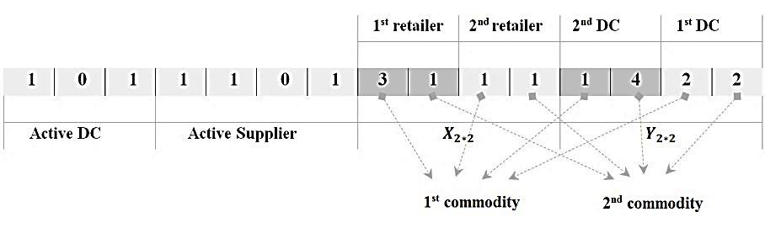
Figure 2. A Case in Chromosome Representation
As the Figure 2 shows, the generated chromosome is containing 4 parts. The DCs 1 & 3 both are active DCs and the DC 2 is null. Second part also refers that suppliers 1, 2, & 4 are a set of active suppliers. 3rd portion of the chromosome contain a stochastic chain between active DCs (1 & 3) that its length is equal to "number of retailers × number of commodities". This section divided into subsets (number of retailers) per se, and length of each one is equal to the number of commodities. This section tells that 1st retailer delivers 1st commodity from 3rd DC and 2nd commodity from 1st DC. Also 2nd retailer delivers both 1st and 2nd commodities from 1st DC. Last portion of chromosome have stochastic chain between active suppliers (i.e. 1, 2, & 4) that its length is equal to "active DCs × number of commodities". This section also divided into subsets (coincide with number of DCs) that the length of each one is equal to the number of commodities. This section tells that the 1st active DC (number 1) procure the 1st commodity from 1st supplier and 2nd commodity from 4th supplier, and also the 2nd active DC (number 3) procure its both commodities from 2nd supplier. (Note that the length of this section varies according to the number of active DCs).

Initial Population Generation
First population would be generates according to the described procedure in section ‎4-4-1.

Selection
This operator acts as Tournament [51] for NSGA-II and PESA-II, and Roulette Wheel [51] for NRGA.

Crossover
For this operator, three methods of Single-Point Crossover, Two-point Crossover and Uniform Crossover are supposed as possible operations for optimizer algorithms. In crossover each part of the parent chromosome combines with the same one in another parent chromosome. Note that it's possible to be extended as though in a specific portion, multiple portions, or even all parts of the parents’ chromosome. Also it’s possible that an offspring chromosome be an unfeasible one, since its 3rd and 4th parts are generated by 1st and 2nd parts. Overcoming such a problem, the Repairing Procedure comes in handy. In another word, the genes in 3rd and 4th parts each of which may causes infeasible offspring chromosomes could be substituted by stochastic numbers between active DCs (in 3rd) and between active suppliers (in 4th) (Figure 3).

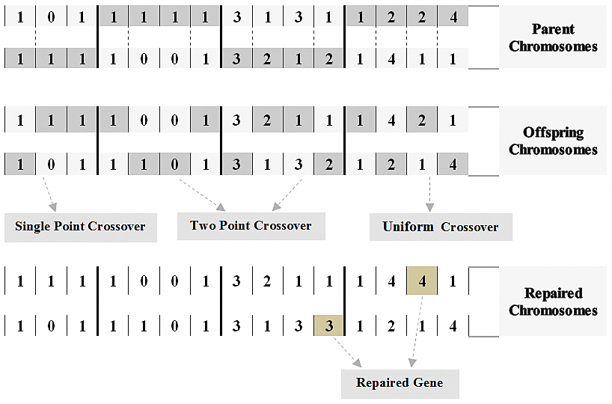
Figure 3. Crossover Operators and Repair Procedure for the Presented Chromosome

Mutation
This operator as crossover may affect in one or more portion of a chromosome. For 1st and 2nd which are Boolean, stochastically a specific percent of the genes would be selected and changed (null to active or active to null) [51]. For 3rd and 4th portion presumably a specific percent might be changed but the stochastically selected gene(s) could be substituted with active set of DCs (for 3rd) or active set of suppliers (for 4th). Note that like crossover, after operation the produced chromosome might be an infeasible one that requires the mentioned repairing process.

Termination Condition
As clears by its name, it determines the circumstance for ceasing iteration. For applied algorithms the index of termination condition in this paper is a specific number of iterations dictated by calibration method explained in section Error! Reference source not found..

.Experimental Results
Till now, the problem background and its formulation explained comprehensively. The algorithms for solving the problem and their common characteristics have explained in detail. Now the obtained results by coded MO-Algorithms are going to be explained and exposed as follow.

NSGA-II
The produced results by this algorithm reported in Figure 4.

Figure 4. Generated Pareto Front by NSGA-II

NRGA
As pronounced, the different between this algorithm and NSGAII is in their member selection. This algorithm uses Roulette Wheel based upon the sorting for parent selection, which is a modified usage of generic Roulette Wheel. According to this modification, the possibility of selection a member like i from population is equal to P_{i} and could be calculated by Formula ‎(19).
$$P_{i}=\frac{2*{Rank}_{i }}{nPop*\left(nPop+1\right)}$$ | - .
Note that the N is population size, and ${Rank}_{i}$ is i^{th} member rank in population. The results of this algorithm exposed in Figure 5.

Figure 5. Generated Pareto Front by NRGA

PESA-II
As mentioned, this algorithm has a grid internal archive memory, saving best obtained solutions through the each iteration. Reaching to such an issue, it makes objective function space reticulated and devotes a number to every container place that is equal with the existing population size in that place. So there is no need in calculating the Rank and Crowding Distance for every member in the sort and only a number devoted to places containing archive population. This reduces calculation load and makes the algorithm operation faster. The produced results by this algorithm presented in Figure 6.

Figure 6. Generated Pareto Front by PESA-II

Emerged Pareto Fronts in a specific run for three applied algorithms exposed as Figure 7 altogether.

Figure 7. Generated Pareto Front by Triplex Algorithms

4. Comparison
Non-Dominated result could be compared through different criteria as CPU Time, Ratio of Non-dominated Individuals (RNI), Uniformly Distribution (UD), Diversity, Coverage of Two Set (C), and Quality Metric (QM) each of which explained beneath:

CPU Time
It induces the processing time of each algorithm, and the lower value for this criterion the better.

Ratio of Non-dominated Individuals (RNI)
The RNI criterion [52], determines the ratio of non-dominated member numbers to the total population (Eq. ‎(20)) (n = number of identified points in Pareto Front (${PF}_{Known}$), $nPop$ = number of population).
$$RNI=\frac{n}{nPop}$$ | - .
Clearly for this criterion, the more RNI value approaching to unit (i.e. 1) the better.

Uniformly Distribution (UD) of Pareto Front
The Uniformly Distribution of Pareto Front could be calculated by Schott’s Spacing (SS) Metric [53]. (Formula ‎(21))

$$SS=\sqrt{\frac{1}{n-1}\sum_{i=1}^{n}{{\left(\overline{d}-d_{i}\right)}^{2}}}$$  $$d_{i}=\min_{j}{(\sum_{k=1}^{nObj}{|f_{k}^{i}-f_{k}^{j}|})}; ∀i,j=1,2,…n,i≠j$$  $$\overline{d}=\frac{1}{n}\sum_{i=1}^{n}{d_{i}}$$ | - .
While:
$f_{k}^{i}$= k^{th} value of objective function in i^{th} ${PF}_{Known}$ Point
$nObj$ = number of objective
The Schott’s Spacing (SS) Metric is in inverse relationship with Uniformly Distribution (Formula ‎(22)). Clearly for this criterion, the higher Uniformly Distribution value, the more utility.
$$UD=\frac{1}{1+SS}$$ | - .

Diversity of Pareto Front
The Diversity of Pareto Front solutions could be calculated using Formula ‎(23) and of course the bigger value for this criterion the better utility.
$$Diversity=\sum_{k=1}^{nObj}{\max_{i,j}{|f_{k}^{i}-f_{k}^{j}|}}; ∀i, j=1,2,…,n$$ | - .

Quality Metric (QM)
The quality of came in hand solutions could be considerable by this criterion [55]. Measuring needs combining the all obtained results by triplex algorithms so that with a complete comparison between them, the global non-dominated points (signed as set of ${PT}^{*}$), could be determined. The QM value is equal with the number of each algorithm’s non-dominated points (entitled to be members of ${PT}^{*}$), divided to the total number of non-dominated point of this specific algorithm as Formula ‎(24):
$${QM}_{l}=\frac{\left|{PT}_{l}∈{PT}^{*}\right|}{\left|{PT}_{l}\right|}$$ | - .
The results for three applied algorithm presented in Figure 11 - Error! Reference source not found. as bellow:
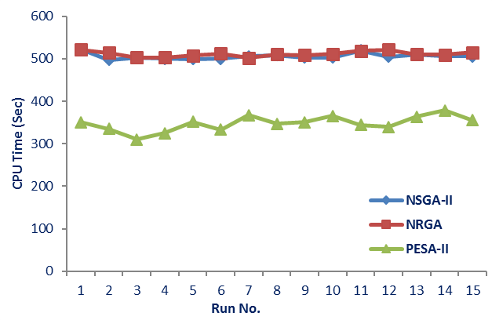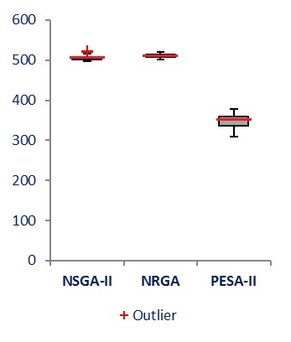
Figure 8. Line Plot and Box Plot for CPU Time

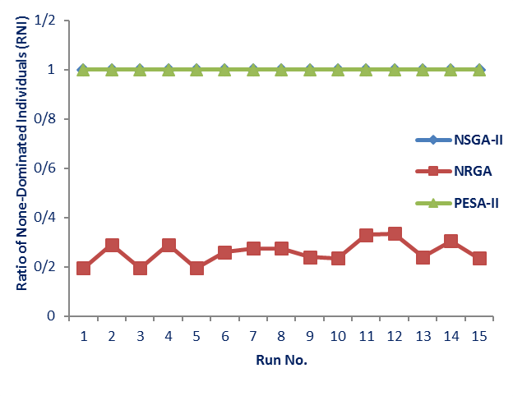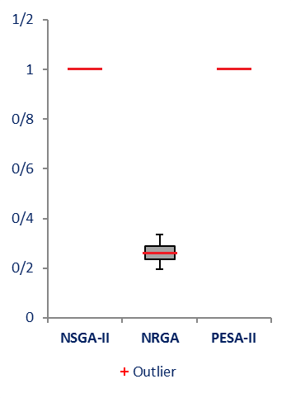
Figure 9. Line Plot and Box Plot for RNI

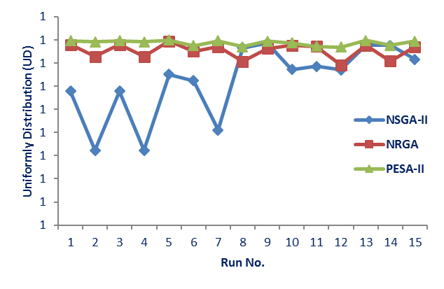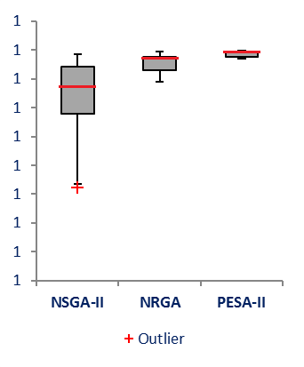
Figure 10. Line Plot and Box Plot for UD

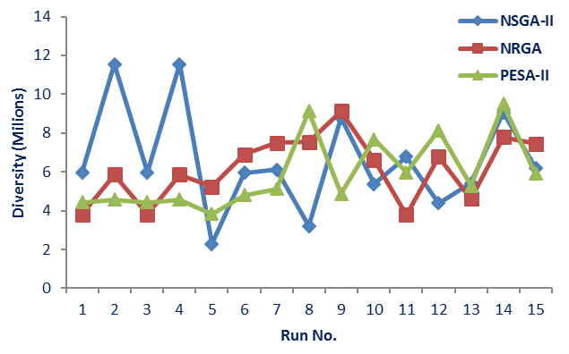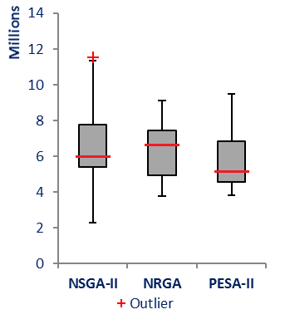
Figure 11. Line Plot and Box Plot for Diversity

Discussion
Now and after applying the triplex evolutionary calibrated algorithms, it is time to have an analysis and explanation on experimental results. So, a comparison on algorithm run time as exposed in Figure 11, NSGA-II and NRGA CPU Time almost are same, whilst PESA-II needs less processing time rather than the others (almost two-third in compare with the others). Invoking RNI criterion, Figure 12 reveals the same values for NSGA-II and PESA-II each of which are much more than what reported for NRGA. In another comparison presented in Figure 13, based upon the Uniformly Distribution of Pareto Front, one can clearly find that PESA-II has the highest value that follows by NRGA, and the last is NSGA-II of course. Figure 14 considers the Solution Diversities for applied algorithm and as exposed there is no significant differentiation between them. QM for non-dominated solutions for each one presented in Error! Reference source not found. that says in this criterion, NRGA possesses has the highest value and NSGA-II after it catches the 2nd order, so clear that PESA-II comes at last.
Last but not least, the Coverage of Two Set (C) index presented in Error! Reference source not found.. As a case, the upper corner graph on left hand side, shows C(NSGA-II, NSGA-II), C(NSGA-II, NRGA), and C(NSGA-II, PESA-II). Note that this criterion in case an algorithm compared by itself turns null value ( C(NSGA-II, NSGA-II)=0 ). All in all, one could judge and extract this statement that in term of a criterion like C, NRGA has the best condition, the circumstance that follows by NSGA-II, while PESA-II catches the lowest rank.

4. Concluding Remarks and Future Works
In this innovative paper, a mathematical formulation has been developed for a tri-echelon Supply Chain Network as a MINLP. Since the proposed model of this paper was hard to be resolved analytically or with exact methods, three ones of GA-based algorithms called Non-dominated Sorting Genetic Algorithm (NSGA-II), Non-dominated Ranking Genetic Algorithm (NRGA), and Pareto Envelope-based Selection Algorithm (PESA-II) have been applied and compared to validate the obtained results. After the parameter calibration process, they have been deployed to solve the problem. The comparison results in the end has shown that although NSGA-II and NRGA algorithms turns almost the same measured results by some criteria, the PESA-II significantly does not act as well as two others but clearly it has better CPU time than the others.
Several recommendations could be in mind for future studies, as following four main issues:
- Considering the problem under extra constraint such as shortage costs, discounts or inflation, non-perfect suppliers and DCs, suppliers and DCs set-up time.
- Utilizing other meta-heuristics such as MOGA, MOSA, MOPSO, and MOHS to solve the problem and comparing their performances.
- Using other GA operators for mutation and crossover.
- Invoking queuing models as a hybridized portion for network and also considering some of intake parameters as fuzzy numbers.

References
[1] D. S. Rogers and R. Leuschner, "Supply chain management: retrospective and prospective," Journal of Marketing Theory and Practice, pp. 60-65, 2004.
[2] R. B. Handfield and E. L. Nichols, Introduction to supply chain management vol. 183: prentice Hall Upper Saddle River, NJ, 1999.
[3] A. Amiri, "Designing a distribution network in a supply chain system: Formulation and efficient solution procedure," European Journal of Operational Research, vol. 171, pp. 567-576, 2006.
[4] E. Gebennini, R. Gamberini, and R. Manzini, "An integrated production–distribution model for the dynamic location and allocation problem with safety stock optimization," International Journal of Production Economics, vol. 122, pp. 286-304, 2009.
[5] H. Mohammadi Bidhandi and R. Mohd Yusuff, "Integrated supply chain planning under uncertainty using an improved stochastic approach," Applied Mathematical Modelling, vol. 35, pp. 2618-2630, 2011.
[6] L. V. Snyder, "Facility location under uncertainty: a review," IIE Transactions, vol. 38, pp. 547-564, 2006.
[7] D. N. P. Murthy, O. Solem, and T. Roren, "Product warranty logistics: Issues and challenges," European Journal of Operational Research, vol. 156, pp. 110-126, 7/1/ 2004.
[8] H. Van Landeghem and H. Vanmaele, "Robust planning: a new paradigm for demand chain planning," Journal of operations management, vol. 20, pp. 769-783, 2002.
[9] R. Jamshidi, S. M. T. Fatemi Ghomi, and B. Karimi, "Multi-objective green supply chain optimization with a new hybrid memetic algorithm using the Taguchi method," Scientia Iranica, vol. 19, pp. 1876-1886, 12// 2012.
[10] L. A. Moncayo-Martínez and D. Z. Zhang, "Multi-objective ant colony optimisation: A meta-heuristic approach to supply chain design," International Journal of Production Economics, vol. 131, pp. 407-420, 5// 2011.
[11] Y. Cardona-Valdés, A. Álvarez, and J. Pacheco, "Metaheuristic procedure for a bi-objective supply chain design problem with uncertainty," Transportation Research Part B: Methodological, vol. 60, pp. 66-84, 2// 2014.
[12] B. L. Shankar, S. Basavarajappa, J. C. Chen, and R. S. Kadadevaramath, "Location and allocation decisions for multi-echelon supply chain network–a multi-objective evolutionary approach," Expert Systems with Applications, vol. 40, pp. 551-562, 2013.
[13] M. Marufuzzaman, S. D. Eksioglu, and Y. Huang, "Two-stage stochastic programming supply chain model for biodiesel production via wastewater treatment," Computers & Operations Research, vol. 49, pp. 1-17, 9// 2014.
[14] D. Simchi-Levi, P. Kaminsky, and E. Simchi-Levi, Designing and Managing the Supply Chain: Concepts, Strategies, and Case Studies: McGraw-Hill/Irwin, 2003.
[15] A. Weber and C. J. Friedrich, "Alfred Weber's theory of the location of industries," 1929.
[16] S. L. Hakimi, "Optimum locations of switching centers and the absolute centers and medians of a graph," Operations research, vol. 12, pp. 450-459, 1964.
[17] M. Daskin, "Network and discrete location: models, algorithms and applications," Journal of the Operational Research Society, vol. 48, pp. 763-763, 1997.
[18] R. L. Church and C. S. ReVelle, "Theoretical and Computational Links between the p‐Median, Location Set‐covering, and the Maximal Covering Location Problem," Geographical Analysis, vol. 8, pp. 406-415, 1976.
[19] A. Warszawski and S. Peer, "Optimizing the location of facilities on a building site," Journal of the Operational Research Society, vol. 24, pp. 35-44, 1973.
[20] A. M. Geoffrion and G. W. Graves, "Multicommodity distribution system design by Benders decomposition," Management science, vol. 20, pp. 822-844, 1974.
[21] P. B. Mirchandani and R. L. Francis, Discrete location theory, 1990.
[22] Z.-J. M. Shen, C. Coullard, and M. S. Daskin, "A joint location-inventory model," Transportation Science, vol. 37, pp. 40-55, 2003.
[23] R. Sridharan, "The capacitated plant location problem," European Journal of Operational Research, vol. 87, pp. 203-213, 1995.
[24] R. H. Ballou, "Dynamic warehouse location analysis," Journal of Marketing Research, pp. 271-276, 1968.
[25] A. J. Scott, "Dynamic location-allocation systems: some basic planning strategies," Environment and Planning, vol. 3, pp. 73-82, 1971.
[26] G. O. Wesolowsky and W. G. Truscott, "The Multiperiod Location-Allocation Problem with Relocation of Facilities," Management Science, vol. 22, pp. 57-65, 1975.
[27] D. Erlenkotter, "A comparative study of approaches to dynamic location problems," European Journal of Operational Research, vol. 6, pp. 133-143, 1981.
[28] A. Azapagic and R. Clift, "The application of life cycle assessment to process optimisation," Computers & Chemical Engineering, vol. 23, pp. 1509-1526, 1999.
[29] C.-L. Chen and W.-C. Lee, "Multi-objective optimization of multi-echelon supply chain networks with uncertain product demands and prices," Computers & Chemical Engineering, vol. 28, pp. 1131-1144, 2004.
[30] Z. Zhou, S. Cheng, and B. Hua, "Supply chain optimization of continuous process industries with sustainability considerations," Computers & Chemical Engineering, vol. 24, pp. 1151-1158, 2000.
[31] E. H. Sabri and B. M. Beamon, "A multi-objective approach to simultaneous strategic and operational planning in supply chain design," Omega, vol. 28, pp. 581-598, 2000.
[32] L. K. Nozick and M. A. Turnquist, "Inventory, transportation, service quality and the location of distribution centers," European Journal of Operational Research, vol. 129, pp. 362-371, 2001.
[33] Z. L. Chen, "Integrated production and distribution operations: Taxonomy, models, and review," INTERNATIONAL SERIES IN OPERATIONS RESEARCH AND MANAGEMENT SCIENCE, pp. 711-746, 2004.
[34] G. M. Kopanos, J. M. Laínez, and L. Puigjaner, "An efficient mixed-integer linear programming scheduling framework for addressing sequence-dependent setup issues in batch plants," Industrial & Engineering Chemistry Research, vol. 48, pp. 6346-6357, 2009.
[35] S. C. Graves and S. P. Willems, "Optimizing the Supply Chain Configuration for New Products," Manage. Sci., vol. 51, pp. 1165-1180, 2005.
[36] D. E. Goldberg, "E.(1989). Genetic algorithms in search, optimization and machine learning," Reading: Addison-Wesley, 1990.
[37] C.-L. Hwang, A. S. M. Masud, S. R. Paidy, and K. P. Yoon, Multiple objective decision making, methods and applications: a state-of-the-art survey vol. 164: Springer Berlin, 1979.
[38] K. Deb, A. Pratap, S. Agarwal, and T. Meyarivan, "A fast and elitist multiobjective genetic algorithm: NSGA-II," Evolutionary Computation, IEEE Transactions on, vol. 6, pp. 182-197, 2002.
[39] O. Al Jadaan, C. Rao, and L. Rajamani, "Parametric study to enhance genetic algorithm performance, using ranked based roulette wheel selection method," in International Conference on Multidisciplinary Information Sciences and Technology (InSciT2006), 2006, pp. 274-278.
[40] C.-F. Tsai and K.-M. Chao, "Chromosome refinement for optimising multiple supply chains," Information Sciences, vol. 179, pp. 2403-2415, 2009.
[41] K.-J. Wang, B. Makond, and S. Y. Liu, "Location and allocation decisions in a two-echelon supply chain with stochastic demand – A genetic-algorithm based solution," Expert Systems with Applications, vol. 38, pp. 6125-6131, 5// 2011.
[42] A. Prakash, F. T. S. Chan, H. Liao, and S. G. Deshmukh, "Network optimization in supply chain: A KBGA approach," Decision Support Systems, vol. 52, pp. 528-538, 1// 2012.
[43] F. Altiparmak, M. Gen, L. Lin, and T. Paksoy, "A genetic algorithm approach for multi-objective optimization of supply chain networks," Computers & Industrial Engineering, vol. 51, pp. 196-215, 2006.
[44] S. Bandyopadhyay and R. Bhattacharya, "Solving a tri-objective supply chain problem with modified NSGA-II algorithm," Journal of Manufacturing Systems, vol. 33, pp. 41-50, 2014.
[45] K. Sourirajan, L. Ozsen, and R. Uzsoy, "A genetic algorithm for a single product network design model with lead time and safety stock considerations," European Journal of Operational Research, vol. 197, pp. 599-608, 2009.
[46] S. H. Zegordi, I. N. K. Abadi, and M. A. B. Nia, "A novel genetic algorithm for solving production and transportation scheduling in a two-stage supply chain," Computers & Industrial Engineering, vol. 58, pp. 373-381, 4// 2010.
[47] K. Deb, S. Agrawal, A. Pratap, and T. Meyarivan, "A fast elitist non-dominated sorting genetic algorithm for multi-objective optimization: NSGA-II," Lecture notes in computer science, vol. 1917, pp. 849-858, 2000.
[48] M. H. Alavidoost and M. A. Nayeri, "Proposition of a hybrid NSGA-II algorithm with fuzzy objectives for bi-objective assembly line balancing problem," in Tenth International Industrial Engineering Conference, 2014.
[49] O. Al Jadaan, L. Rajamani, and C. Rao, "Non-dominated ranked genetic algorithm for solving constrained multi-objective optimization problems," Journal of Theoretical & Applied Information Technology, vol. 5, pp. 640-651, 2009.
[50] D. W. Corne, N. R. Jerram, J. D. Knowles, and M. J. Oates, "PESA-II: Region-based selection in evolutionary multiobjective optimization," in Proceedings of the Genetic and Evolutionary Computation Conference (GECCO’2001, 2001.
[51] R. L. Haupt and S. E. Haupt, Practical genetic algorithms: Wiley-Interscience, 2004.
[52] K. C. Tan, T. H. Lee, and E. F. Khor, "Evolutionary algorithms for multi-objective optimization: performance assessments and comparisons," Artificial intelligence review, vol. 17, pp. 251-290, 2002.
[53] J. Knowles and D. Corne, "On metrics for comparing nondominated sets," in Evolutionary Computation, 2002. CEC'02. Proceedings of the 2002 Congress on, 2002, pp. 711-716.
[54] E. Zitzler and L. Thiele, "Multiobjective evolutionary algorithms: a comparative case study and the strength Pareto approach," Evolutionary Computation, IEEE Transactions on, vol. 3, pp. 257-271, 1999.
[55] M. Rabiee, M. Zandieh, and P. Ramezani, "Bi-objective partial flexible job shop scheduling problem: NSGA-II, NRGA, MOGA and PAES approaches," International Journal of Production Research, vol. 50, pp. 7327-7342, 2012.
[56] R. Ruiz, C. Maroto, and J. Alcaraz, "Two new robust genetic algorithms for the flowshop scheduling problem," Omega, vol. 34, pp. 461-476, 2006.
[57] D. C. Montgomery, Design and analysis of experiments: John Wiley & Sons, 2008.
[58] G. Taguchi, Introduction to quality engineering: designing quality into products and processes, 1986.
[59] M. Alavidoost, M. F. Zarandi, M. Tarimoradi, and Y. Nemati, "Modified genetic algorithm for simple straight and U-shaped assembly line balancing with fuzzy processing times," Journal of Intelligent Manufacturing, pp. 1-24, 2014.
[60] B. Naderi, M. Zandieh, A. Khaleghi Ghoshe Balagh, and V. Roshanaei, "An improved simulated annealing for hybrid flowshops with sequence-dependent setup and transportation times to minimize total completion time and total tardiness," Expert Systems with Applications, vol. 36, pp. 9625-9633, 2009.

Key Performance Indicator
Reliable Facility Location Problem
Ant Colony
Tabu Search
Multi-Objective Hybrid Particle Swarm Optimization
Mixed-Integer Nonlinear Programming
Non-Dominated Sorting Genetic Algorithm
Non-Dominated Ranking Genetic Algorithm
Pareto Envelope-Based Selection Algorithm
Some Multi-Criteria Decision Making
Single-Objective Evolutionary Algorithm
Genetic Algorithm
Particle Swarm Optimization
Simulated Annealing
Harmony Search Algorithm
Imperialist Competition Algorithm
Multi-Objective Evolutionary Algorithm
Knowledge-Based Genetic Algorithm
Lagrangian Heuristic Approach
Ranked-Based Roulette Wheel
Pareto-Based Population-Ranking Algorithm

